Aimee Steinwand
BIOS 6624
Project 4 Final Report
Introduction & Background
Variable selection is a fundamental challenge in the development of linear regression models, particularly in settings where many candidate predictors are available but only a subset is truly associated with the outcome. Identifying the correct set of predictors is critical: including irrelevant variables inflates variance and reduces interpretability, while omitting true predictors introduces bias and reduces statistical power. A range of methods have been proposed to address this problem, from classical stepwise procedures based on hypothesis testing criteria to modern penalized regression approaches. Prior simulation work has demonstrated that the performance of these methods can vary substantially depending on the degree of multicollinearity among predictors, the magnitude of true effects, and the sample size available (Chong & Jun, 2005).
The goal of this simulation study is to evaluate the performance of five variable selection approaches in linear regression: backward elimination by p-value, AIC-based selection, BIC-based selection, lasso, and elastic net, across scenarios that vary sample size and predictor correlation structure. For the penalized methods, two tuning strategies are investigated: selection of the penalty parameter λ via cross-validation minimizing mean squared error (λ_min) and via the one-standard-error rule (λ_1se), yielding seven method-tuning combinations in total. Performance is assessed in terms of each method's ability to correctly identify the five true predictors, avoid false inclusion of the fifteen null predictors, produce unbiased coefficient estimates for retained variables, and achieve nominal 95% confidence interval coverage.
Model Notation
Let $Y_{i}$denote the continuous outcome for subject $i$, where $i=1,…,N$. The data are generated under a standard linear regression model:
$$Y_{i}=β_{0}+\sum_{j=1}^{p}{X_{ij}β_{j}+ε_{i}, } ε_{i}\sim N(0,1)$$
where $p=20$candidate predictors are included in the full model. Of these, $p_{1}=5$predictors ($X_{1}-X_{5}$) have nonzero coefficients with true values:
$$β=\left(\frac{0.5}{3}, \frac{1.0}{3},\frac{1.5}{3},\frac{2.0}{3},\frac{2.5}{3},0,0,…,0 \right)$$
The remaining $p_{0}=15$predictors ($X_{6}-X_{20}$) have true coefficients of zero and serve as null predictors. The predictor vector $X_{i}=(X_{i1},…,X_{i20})^{T}$ is drawn from a multivariate normal distribution with mean zero and an exchangeable covariance structure, such that $\text{Corr}(X_{ij},X_{ik})=ρ$ for all $j≠k$. Scenarios with $ρ=0$correspond to independent predictors, while $ρ=0.35$and $ρ=0.70$introduce moderate and high correlation, respectively.
Methods
Five variable selection approaches were evaluated, yielding seven method-tuning combinations in total. All methods began from the full model containing all 20 candidate predictors.
Backward Elimination by P-value. Beginning with the saturated model, variables were removed sequentially based on the least significant F-test statistic, with removal continuing until all remaining variables met a retention threshold of α = 0.05. This procedure was implemented using the step() function in R with the penalty parameter set to k = qchisq(0.95, 1).
AIC-Based Backward Selection. Backward stepwise selection was performed minimizing the Akaike Information Criterion (AIC) at each step, implemented via step() with k = 2. AIC balances model fit against complexity with a fixed penalty of 2 per parameter, and tends to favor slightly larger models than BIC (Tibshirani, 1996).
BIC-Based Backward Selection. Backward stepwise selection was performed minimizing the Bayesian Information Criterion (BIC), implemented via step() with k = log(N). BIC applies a heavier penalty for model complexity than AIC, scaling with sample size, and is known to be consistent. Selecting the true model with probability approaching 1 as N → ∞ under correct model specification.
Lasso Regression. The lasso (Tibshirani, 1996) minimizes the residual sum of squares subject to an L1 penalty on the coefficient vector, shrinking some coefficients exactly to zero and thereby performing simultaneous estimation and variable selection. The tuning parameter λ was selected via 10-fold cross-validation using two rules: (i) λ_min, which minimizes the cross-validated mean squared error, and (ii) λ_1se, which selects the largest λ within one standard error of the minimum, yielding a more parsimonious model. Predictors with nonzero coefficients at the chosen λ were considered selected.
Elastic Net Regression. The elastic net (Zou & Hastie, 2005) combines the L1 penalty of the lasso with the L2 penalty of ridge regression via a mixing parameter α, where α = 1 reduces to the lasso and α = 0 reduces to ridge. A mixing parameter of α = 0.5 was used, reflecting an equal weighting of the two penalties. This approach retains the variable selection property of the lasso while improving stability in the presence of correlated predictors. As with lasso, λ was selected using both λ_min and λ_1se via 10-fold cross-validation.
Post-Selection Inference. For all methods, once a final set of variables was selected, an ordinary least squares (OLS) model was refit on only those selected variables, and inference (coefficient estimates, standard errors, and confidence intervals) was drawn from this refitted model as though no variable selection had been performed. This approach is standard in practice but is known to introduce bias in coefficient estimates and anti-conservative confidence interval coverage, since the selection step and the inference step are not independent (Tibshirani, 1996; Chong & Jun, 2005). This limitation is acknowledged and discussed in the context of the results.
Simulation
Data were generated using the hdrm package in R across six simulation scenarios defined by crossing two sample sizes (N = 250, N = 500) with three levels of exchangeable predictor correlation (ρ = 0, 0.35, 0.70). In each scenario, 2,500 replications were performed, a number chosen to ensure a Monte Carlo standard error of no greater than 0.01 for a proportion near 0.5, derived from the formula $\text{MCSE}=\sqrt{p(1-p)/B}$ where B is the number of replications. Simulations were distributed across 12 parallel cores using the future.apply package in R with a global seed of 42 to ensure reproducibility.
At each replication, a dataset of N observations was generated from the linear model described in the Model Notation section. Predictor variables were drawn from a multivariate normal distribution with mean zero and an exchangeable correlation structure parameterized by ρ. All seven method-tuning combinations were applied to each simulated dataset. For the lasso and elastic net, the penalized model was fit using cv.glmnet() from the glmnet package with 10-fold cross-validation and predictors standardized prior to fitting. Variables with nonzero coefficients at the chosen λ were considered selected, and an OLS model was then refit on the selected variables for inference.
The following performance metrics were computed at the variable level for each replication. True positive rate (TPR) was defined as the proportion of replications in which each of the five true predictors (X1–X5) appeared in the final selected model. False positive rate (FPR) was defined as the proportion of replications in which each of the 15 null predictors (X6–X20) was incorrectly selected. A confusion matrix summarizing mean true positive, false positive, true negative, and false negative counts per replication was also constructed. For variables retained in the final model, bias was computed as the difference between the estimated and true coefficient, with non-selected variables assigned an implicit estimate of zero. Coverage was defined as the proportion of replications in which the 95% confidence interval from the refitted OLS model contained the true coefficient value; for non-selected true predictors, coverage was assigned as 0, and for non-selected null predictors, coverage was assigned as 1, reflecting the convention that an unselected variable is implicitly treated as having a coefficient of zero. Type I error was computed among null predictors that were selected and tested in the refitted model, defined as the proportion of replications yielding a statistically significant result at α = 0.05. Type II error was computed for true predictors and defined as the proportion of replications in which the variable was either not selected or, if selected, failed to reach significance at α = 0.05 in the refitted model.
Results were summarized in tables reporting each metric by method, sample size, and correlation level. Bar plots depicting mean TPR and FPR across methods and scenarios were produced, along with a line plot of 95% CI coverage to facilitate visual comparison against the nominal 95% level.

Results & Discussion
Results are presented across six simulation scenarios defined by sample size (N = 250, N = 500) and exchangeable predictor correlation (ρ = 0, 0.35, 0.70) for all seven method-tuning combinations. Performance is evaluated in terms of true positive rate, false positive rate, coefficient bias, 95% CI coverage, and Type I and Type II error.
True Positive Rate
Figure 1 displays the mean TPR, the proportion of replications in which each true predictor (X1–X5) was included in the final selected model, averaged across the five true predictors by method and scenario. Overall, most methods performed well in recovering the true predictors, with the majority exceeding 90% TPR across scenarios. EN05_min achieved the highest and most consistent TPR, reaching or approaching 100% in nearly all scenarios. LASSO_min and LASSO_1se performed similarly well, with LASSO_min slightly outperforming LASSO_1se, as expected given that λ_1se applies a stronger penalty. AIC and PVAL also performed competitively, generally exceeding 90% TPR. BIC showed the weakest sensitivity, particularly in the high-correlation, small-sample scenario (N = 250, ρ = 0.70), where mean TPR fell to approximately 80%. This is consistent with BIC's heavier complexity penalty, which favors sparser models and can miss true predictors with modest effect sizes. Increasing sample size from N = 250 to N = 500 generally improved TPR across all methods, and the effect of correlation on TPR was most pronounced for BIC.
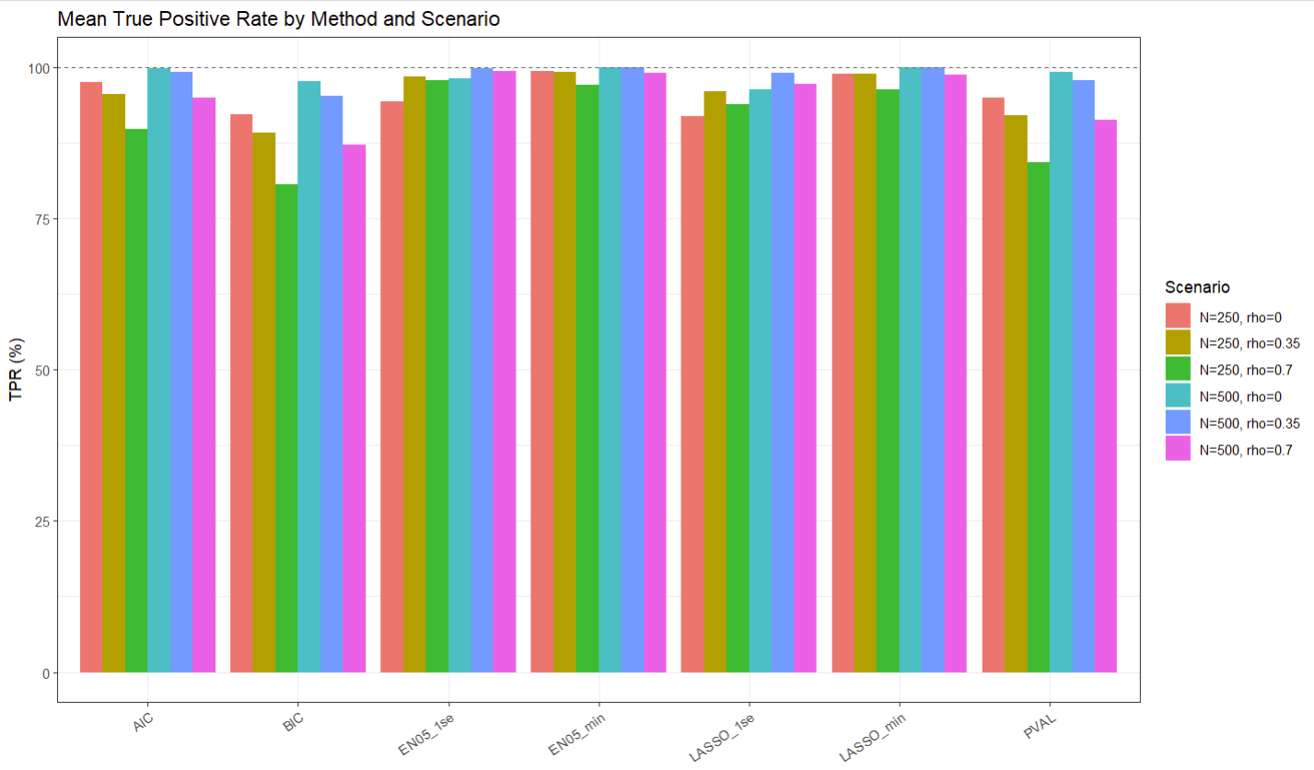
Figure 1: Mean True Positive Rate by Method and Scenario
False Positive Rate
Figure 2 displays the mean FPR, the proportion of replications in which each null predictor (X6–X20) was incorrectly included in the final model, averaged across the 15 null predictors. The results reveal a striking trade-off between sensitivity and specificity across methods. EN05_min and LASSO_min, despite their strong TPR performance, exhibited the highest FPR of all methods, reaching approximately 49% and 40% respectively in the N = 250, ρ = 0 scenario, and exceeding 50% in some N = 500 scenarios. This indicates that while these methods reliably include the true predictors, they do so at the cost of also including large numbers of null predictors. Predictor correlation further inflated FPR for both EN05_min and EN05_1se, with high correlation (ρ = 0.70) producing FPR values exceeding 40% for EN05_1se. In contrast, BIC achieved the lowest FPR across all scenarios, consistently remaining below 3%, reflecting its aggressive penalization of model complexity. PVAL and LASSO_1se struck a more favorable middle ground, with PVAL maintaining FPR near 5–6% across scenarios and LASSO_1se ranging from approximately 2% to 20% depending on correlation level. These results highlight that λ selection has a profound impact on the behavior of penalized methods: λ_min prioritizes prediction accuracy and recovers true predictors reliably but at a high false discovery cost, while λ_1se is considerably more conservative.
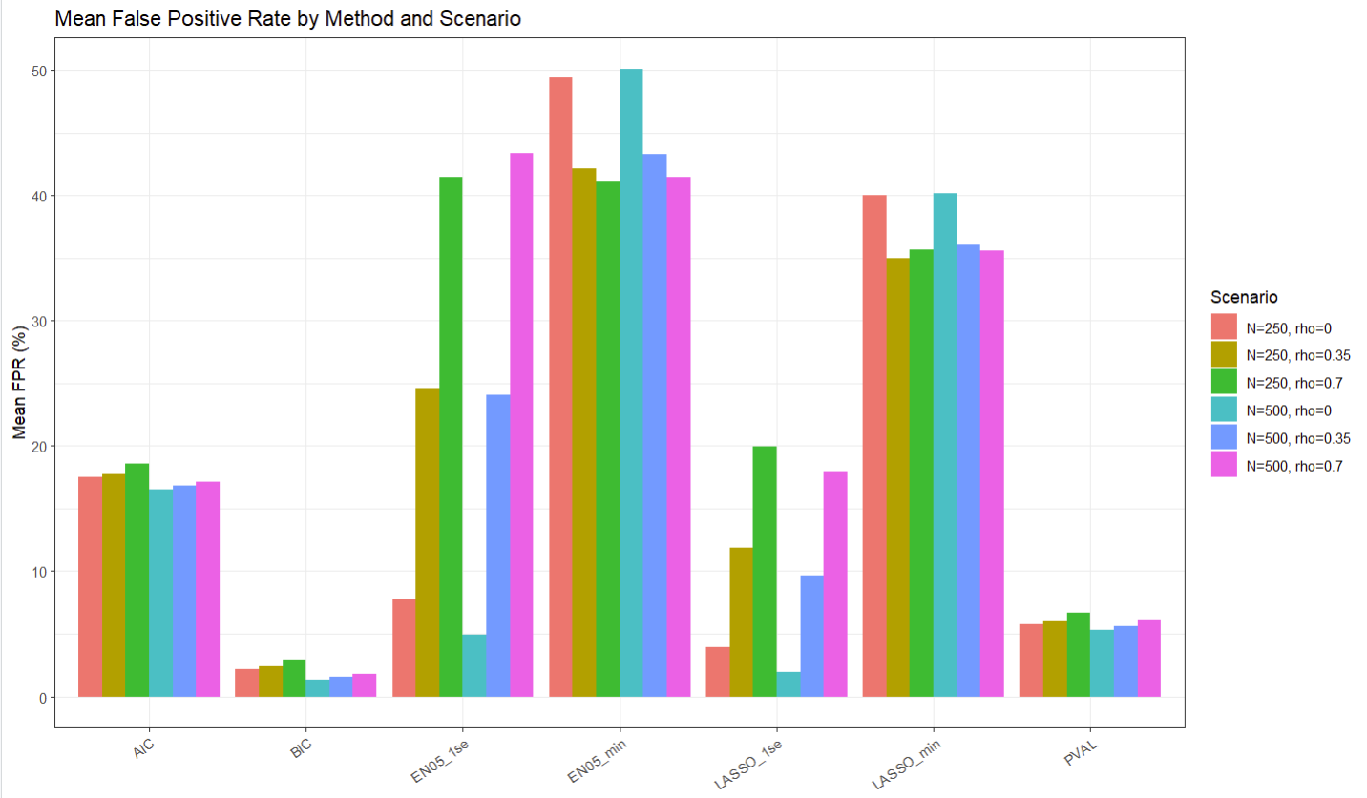
Figure 2: Mean False Positive Rate by Method and Scenario

Confusion Matrix Summary
The confusion matrix results (Table 1 Appendix) corroborate the patterns observed in Figures 1 and 2. Methods with high TPR and high FPR, particularly EN05_min and LASSO_min, accumulated the largest mean false positive counts per replicate, while BIC minimized false positives at the expense of elevated false negatives. PVAL and LASSO_1se achieved the most balanced confusion matrix profiles across scenarios.
Coefficient Bias
Bias results were computed for the five true predictors across all methods and scenarios, with non-selected variables assigned an implicit estimate of zero. Across all methods, bias was most pronounced for the weakest true predictor (X1, β = 0.5/3 ≈ 0.167) and diminished as coefficient magnitude increased toward X5 (β = 2.5/3 ≈ 0.833). This pattern reflects the well-known attenuation bias associated with post-selection inference: variables with smaller true effects are more frequently missed by the selection step, and when their estimate is imputed as zero, the average estimate is pulled toward zero. Methods with lower TPR for weak predictors, particularly BIC, exhibited the largest bias for X1 and X2. Penalized methods using λ_min showed relatively modest bias given their high selection rates, though the shrinkage inherent in the lasso and elastic net introduces some downward bias in estimates even when variables are selected. Larger sample size (N = 500) generally reduced bias across all methods.
95% Confidence Interval Coverage
Figure 3 displays the 95% CI coverage for the true predictors by method and scenario. No method achieved nominal 95% coverage consistently across all scenarios, a finding that underscores the consequences of performing inference after variable selection without correction. The closest approximation to nominal coverage was observed for EN05_min and LASSO_min at N = 500, ρ = 0, where coverage approached 95%. Coverage degraded substantially as predictor correlation increased, with the most severe under-coverage observed for BIC at N = 250, ρ = 0.70, where coverage fell to approximately 74%. This is a direct consequence of BIC's tendency to exclude weakly associated true predictors under high correlation, assigning them an implicit estimate of zero with no associated interval. AIC and PVAL showed moderate under-coverage ranging from approximately 84% to 95% depending on scenario. The consistent below-nominal coverage across all methods confirms that refitting the final selected model as though no selection occurred produces anti-conservative inference, and that this problem is exacerbated under high correlation and small sample sizes.
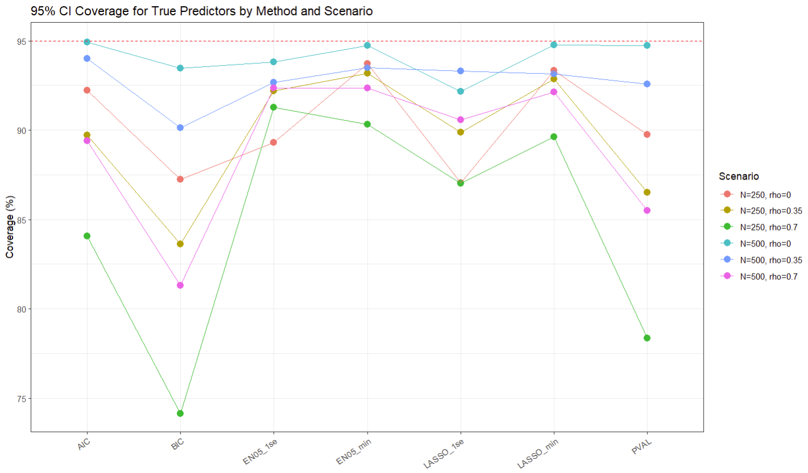
Figure 3: 95% CI Coverage for True Predictors by Method and Scenario
Type I and Type II Error
Type I error results, computed among null predictors that were selected and subsequently tested in the refitted OLS model, were generally well-controlled near the nominal α = 0.05 level across all methods. This is expected, as once a null predictor is included in the refitted model and tested in the absence of any true association, the test behaves approximately as intended. Type II error results, computed for true predictors as the proportion of replications in which the variable was either not selected or failed to reach significance in the refitted model, were most elevated for BIC across all scenarios and were especially high for X1 and X2, reflecting the difficulty of detecting the weakest effects. Methods with high TPR and high FPR, such as EN05_min and LASSO_min, had the lowest Type II error for true predictors, though this came at the cost of the high false positive burden already noted.
Overall Recommendations
No single method dominated across all performance criteria, and the preferred approach depends on the overall goals. When maximizing sensitivity is the priority, EN05_min or LASSO_min are the strongest performers, though high false positive rates make them poorly suited for settings where parsimony matters. BIC is the clear choice when false discovery control is paramount, though be aware of its reduced power under high correlation and modest effect sizes. PVAL and LASSO_1se represent the most balanced approaches overall, offering reasonable sensitivity while maintaining acceptable false positive rates. Regardless of method, high predictor correlation consistently posed the greatest challenge across all metrics, and the universal under-coverage observed confirms that post-selection inference without correction produces anti-conservative results, a limitation that should be addressed through bootstrap-based or selective inference procedures in practice.
Future Work
This project highlighted several directions that would extend the current findings. One next step is to evaluate variable selection methods under more complex correlation structures, such as block‑correlated or autoregressive designs, which more closely resemble real data settings than the exchangeable structure used here. The consistent under‑coverage observed across all methods also suggests the need to investigate formal post‑selection inference procedures, including selective inference, sample‑splitting, or bootstrap‑based adjustments, to determine whether they can restore nominal confidence interval performance.
Another promising extension involves exploring alternative tuning strategies for penalized regression beyond λ_min and λ_1se, such as stability selection or information‑criterion–based tuning for penalized models. Varying the signal‑to‑noise ratio or allowing heterogeneous effect sizes would also provide insight into method performance when true signals are weaker or unevenly distributed. Finally, extending the simulation framework to generalized linear models would help determine whether the patterns observed here generalize to binary or count outcomes commonly encountered in applied research.

Appendix
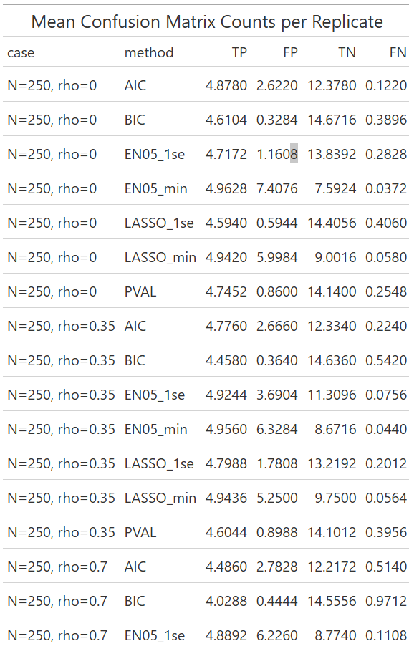
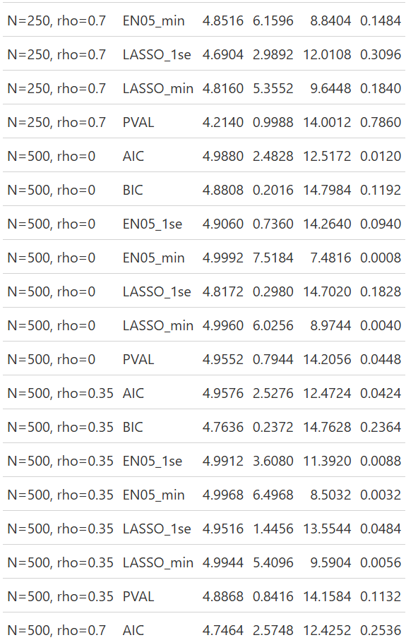
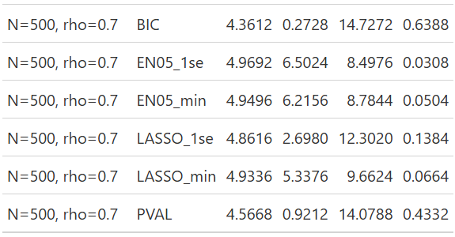
Table 1:

